MINI PROJECT REPORT ON

**Online College Admission System**

**Submitted By**

Radhika Nair (CEB549)

Shivani Rana (CEB563)

Chaitali Roman (CEB566)

**Under the Guidance of**

Prof. Neharika Singh



**DEPARTMENT OF COMPUTER ENGINEERING**

**MES Pillai Institute of Information Technology**

**New Panvel**

**2015-2016**



**CERTIFICATE OF APPROVAL**

**Mini Project Entitled**: **Online College Admission System**

**Submitted by:**

Radhika Nair CEB549

Shivani Rana CEB563

Chaitali Roman CEB566

**In partial fulfillment of the degree of T.E. in “Computer Engineering" is approved.**

______________ **______________**

**Subject Incharge External Examiner**

***ABSTRACT***

*The aim of the project is to build a basic College Admission System using basic web technologies. Using languages like html, PHP and JavaScript, a portal for College Admission can be made. The concept of the project is an Engineering College. Admission to any strem of Engineering depends on a specific Eligibility Criteria and Availability of Seats. The course fees of each student depends on his category. The website will also give basic information about the College, its infrastructure and other facilities and amenities it provides.*

**LIST OF FIGURES**

|  |  |  |
| --- | --- | --- |
| **Fig No.** | **Title** | **Page No.** |
| 4.2.1 | Homepage | 7 |
| 4.2.2 | About Us Page | 7 |
| 4.2.3 | Classroom Page | 8 |
| 4.2.4 | Library Page | 8 |
| 4.2.5 | Playground Page | 9 |
| 4.2.6 | Laboratories Page | 9 |
| 4.2.7 | Computer Engineering Page | 10 |
| 4.2.8 | Mechanical Engineering Page | 10 |
| 4.2.9 | Automobile Engineering Page | 11 |
| 4.2.10 | Electronics and Telecommunication Engineering Page | 11 |
| 4.2.11 | Electronics Engineering Page | 12 |
| 4.2.12 | Eligibility Form Page | 12 |
| 4.2.13  4.2.14  4.2.15  4.2.16  4.2.17  4.2.18 | Eligibility Result Page  Admission Form Page  Fees Payment Page  Admission Confirmation Page  Student Bodies Page  Database :Table "student" | 13  13  14  14  15  15 |
|  |  |  |

**TABLE OF CONTENTS**

**Caption Page No.**

**Abstract ii**

**List of Figures iii**

**Chapter 1**

**Introduction**

* 1. Introduction 01

**Chapter 2**

**Objective**

2.1 Problem Definition 02

2.2 System Requirements 02

**Chapter 3**

**Technologies**

3.1 HTML 03

3.2 CSS 03

3.3 XAMPP 04

3.4 PHP 04

3.5 JAVASCRIPT 04

**Chapter 4**

**Implementation**

4.1 System Overview 06

4.2 Project working with Snapshots 07

**Chapter 5**

**Conclusion**

5.1 Summary 16

5.2 Future Scope 16

**References 17**

**Chapter 01**

**Introduction**

**1.1 Introduction**

This website deals with the online admission to a college named "PILLAI INSTITUTE OF INFORMATION TECHNOLOGY". Students can check basic information about college such as infrastructure, its student bodies, the streams provided by college etc. They can apply for admission only if they fulfill the eligibility criteria and there are seats left in the stream of their choice.

**Chapter 02**

**Objective**

The objective is to be able to see the description of the College and the facilities provided by the College online. Also applying for admission is easy online. The student has to first fill out Eligibility form and then if eligible can directly proceed to Admission form and payment of fess.

**2.1 Problem Definition**

The aim is to develop website, which can manage and keep the records of the students taking admission in the College. The existing system is manual and the students are unable to see details of the College online. With this website, the student can secure admission online on being eligible by filling up simple forms. At the same time, the student's record are inserted and stored in database by running a simple query.

**2.2 System Requirements**

Hardware Configuration

Processor:AMD A10

RAM:8 GB

Hard Disk:1 TB

Modem:Broadband

Software Configuration

Operating System:Windows 8

Web Server: XAMPP

Front End:HTML, CSS

Scripts:JavaScript

Language: PHP , Back End:MySQl

**Chapter 3**

**Technologies**

**3.1 HTML**

HTML is the universal mark-up language for the Web. HTML lets you format text, add graphics, create links, input forms, frames and tables, etc., and save it all in a text file that any browser can read and display. The key to HTML is the tags, which indicates what content is coming up. The first tag in a pair is the start tag, and the second tag is the end tag (they are also called opening tags and closing tags).

A web browser can read HTML files and compose them into visible or audible web pages. The browser does not display the HTML tags, but uses them to interpret the content of the page. HTML describes the structure of a website semantically along with cues for presentation, making it a markup language rather than a programming language.

HTML elements form the building blocks of all websites. HTML allows images and objects to be embedded and can be used to create interactive forms. It provides a means to create structured documents by denoting structural semantics for text such as headings, paragraphs, lists, links, quotes and other items. It can embed scripts written in languages such as JavaScript which affect the behavior of HTML web pages.

**3.2 CSS**

Cascading Style Sheets (CSS) is a style sheet language used for describing the look and formatting of a document written in a markup language. While most often used to change the style of web pages and user interfaces written in HTML and XHTML, the language can be applied to any kind of XML document, including plain XML, SVG and XUL.

Along with HTML and JavaScript, CSS is a cornerstone technology used by most websites to create visually engaging webpages, user interfaces for web applications, and user interfaces for many mobile applications. CSS is designed primarily to enable the separation of document content from document presentation, including elements such as the layout, colors, and fonts. This separation can improve content accessibility, provide more flexibility and control in the specification of presentation characteristics, enable multiple HTML pages to share formatting by specifying the relevant CSS in a separate .css file, and reduce complexity and repetition in the structural content, such as semantically insignificant tables that were widely used to format pages before consistent CSS rendering was available in all major browsers.

**3.3 XAMP**

XAMP is a [free and open source](http://en.wikipedia.org/wiki/Free_software)[cross-platform](http://en.wikipedia.org/wiki/Cross-platform)[web server](http://en.wikipedia.org/wiki/Web_server)[solution stack](http://en.wikipedia.org/wiki/Solution_stack) package, consisting mainly of the [Apache HTTP Server](http://en.wikipedia.org/wiki/Apache_HTTP_Server), [MySQL](http://en.wikipedia.org/wiki/MySQL)[database](http://en.wikipedia.org/wiki/Database), and [interpreters](http://en.wikipedia.org/wiki/Interpreter_(computing)) for scripts written in the [PHP](http://en.wikipedia.org/wiki/PHP). XAMPP requires only one [zip](http://en.wikipedia.org/wiki/ZIP_(file_format)), [tar](http://en.wikipedia.org/wiki/Tar_(file_format)), [7z](http://en.wikipedia.org/wiki/7z), or [exe](http://en.wikipedia.org/wiki/EXE) file to be downloaded and run, and little or no configuration of the various components that make up the web server is required. XAMPP is regularly updated to incorporate the latest releases of [Apache](http://en.wikipedia.org/wiki/Apache_HTTP_Server)/[MySQL](http://en.wikipedia.org/wiki/MySQL)/[PHP](http://en.wikipedia.org/wiki/PHP) and [Perl](http://en.wikipedia.org/wiki/Perl). It also comes with a number of other modules including [OpenSSL](http://en.wikipedia.org/wiki/OpenSSL) and [phpMyAdmin](http://en.wikipedia.org/wiki/PhpMyAdmin).

**3.4 PHP**

PHP is a purpose server language originally designed for [Web development](http://en.wikipedia.org/wiki/Web_development) to produce [dynamic Web pages](http://en.wikipedia.org/wiki/Dynamic_Web_page). It is one of the first developed server-side scripting languages to be embedded into an [HTML](http://en.wikipedia.org/wiki/HTML) source document rather than calling an external file to process data.

The code is [interpreted](http://en.wikipedia.org/wiki/Interpreter_(computing)) by a Web server with a PHP processor module which generates the resulting Web page. It also has evolved to include a [command-line interface](http://en.wikipedia.org/wiki/Command-line_interface) capability and can be used in [standalone](http://en.wikipedia.org/wiki/Computer_software)[graphical applications](http://en.wikipedia.org/wiki/Graphical_user_interface). PHP can be deployed on most Web servers and also as a standalone [shell](http://en.wikipedia.org/wiki/Shell_(computing)) on almost every [operating system](http://en.wikipedia.org/wiki/Operating_system) and [platform](http://en.wikipedia.org/wiki/Computing_platform) free of charge.

**3.5 JAVASCRIPT**

Javascript was engineered at Sun Microsystems with the intention of creating a method of manipulating [webpages](http://what-is-what.com/what_is/webpage.html) on a user's [computer](http://what-is-what.com/what_is/computer.html), without the need for refreshing the page. JavaScript is classified as a [prototype-based](http://en.wikipedia.org/wiki/Prototype-based_programming) [scripting language](http://en.wikipedia.org/wiki/Scripting_language) with [dynamic](http://en.wikipedia.org/wiki/Dynamic_language) typing and [first-class functions](http://en.wikipedia.org/wiki/First-class_functions). This mix of features makes it a [multi-paradigm](http://en.wikipedia.org/wiki/Multi-paradigm) language, supporting [object-oriented](http://en.wikipedia.org/wiki/Object-oriented_programming), [imperative](http://en.wikipedia.org/wiki/Imperative_programming), and [functional](http://en.wikipedia.org/wiki/Functional_programming) programming styles.

The most common use of JavaScript is to add client-side behavior to [HTML](http://en.wikipedia.org/wiki/HTML) pages, a.k.a. [Dynamic HTML](http://en.wikipedia.org/wiki/Dynamic_HTML) (DHTML). Scripts are embedded in or included from [HTML](http://en.wikipedia.org/wiki/HTML) pages and interact with the [Document Object Model](http://en.wikipedia.org/wiki/Document_Object_Model) (DOM) of the page. JavaScript code can run locally in a user's browser (rather than on a remote server), the browser can respond to user actions quickly, making an application more responsive.

**Chapter 4**

**Implementation**

**4.1 System Overview**

The user can browse the whole website and get all the information about the college PILLAI INSTITUTE OF INFORMATION TECHNOLOGY. There is also a ABOUT Us and INFRASTRUCTURE page which the Student can read for further information.

On the Home Page there is also a drop down for Engineering which opens up on mouse over and student can click on the Engineering stream to know more about it. There is also a drop down for Infrastructure as well as for Student Bodies which display different information when a tab on the list is clicked . On clicking the Admission tab student can get information about eligibility criteria as well as fees structure and there is also a link to start Admission process. Once the student has secured admission he gets a confirmation message.

**4.2 Screenshots of Web pages**

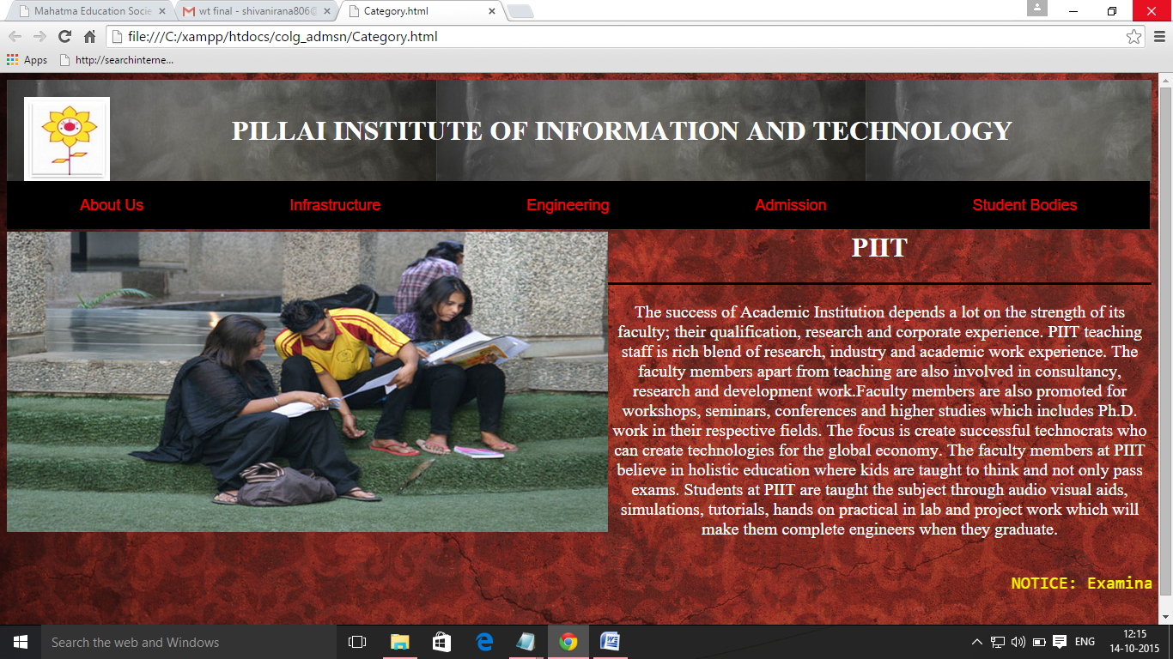

**Fig. 4.2.1: Homepage**

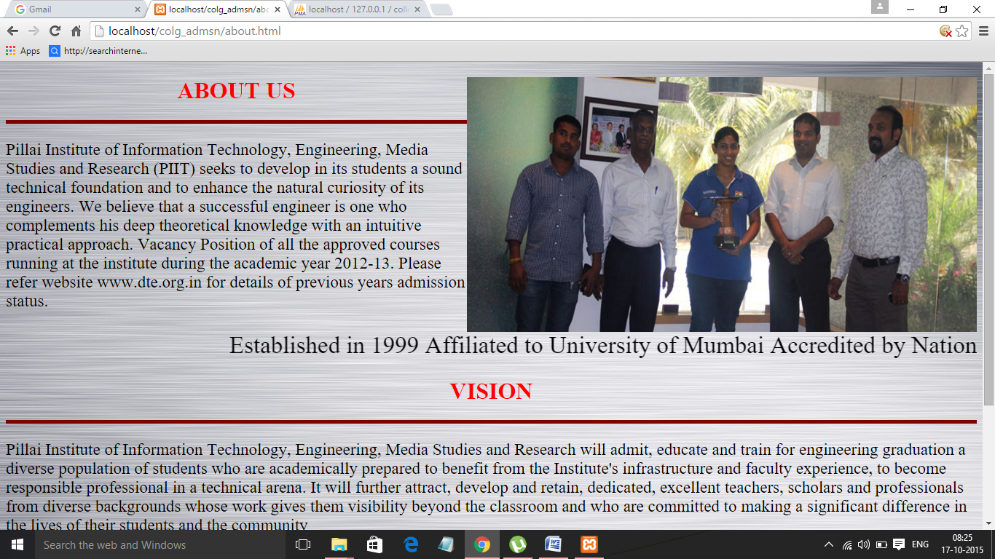

**Fig. 4.2.2:About Us Page**

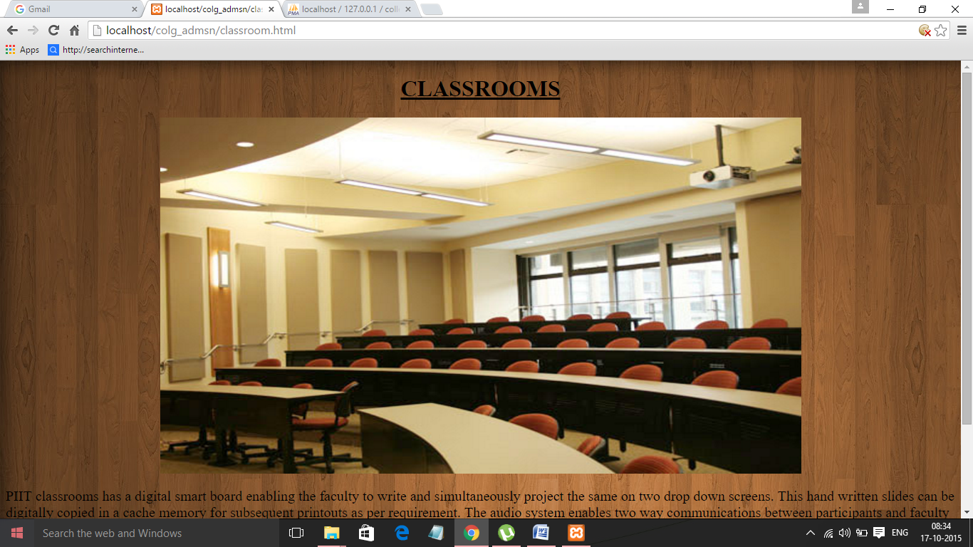

**Fig. 4.2.3:Classroom Page**

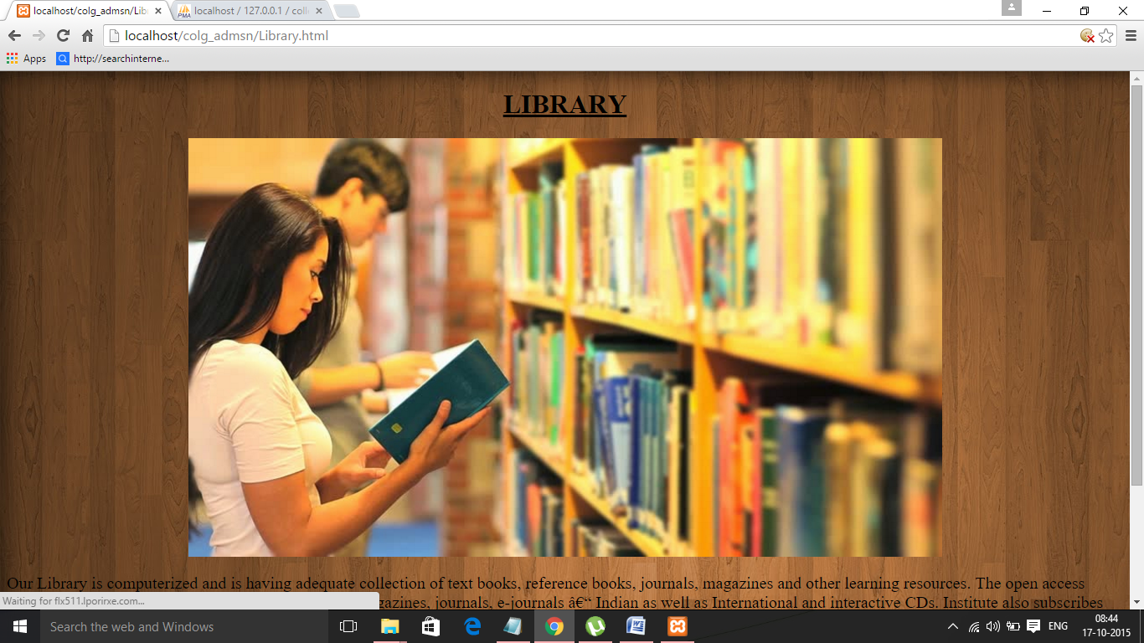

**Fig. 4.2.4:Library Page**

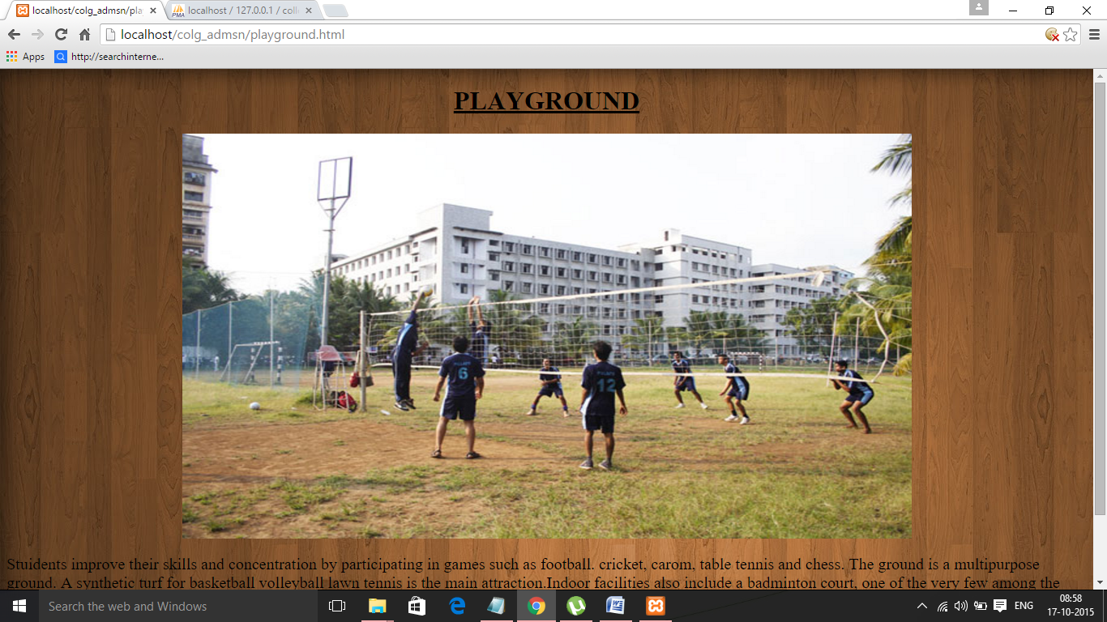

**Fig. 4.2.5:Playground Page**

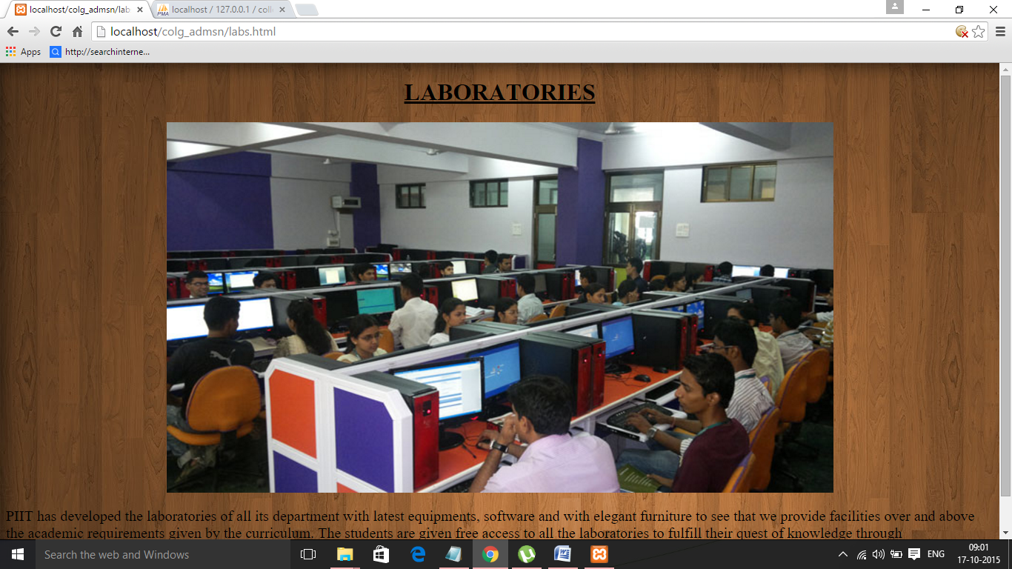

**Fig. 4.2.6:Laboratories Page**

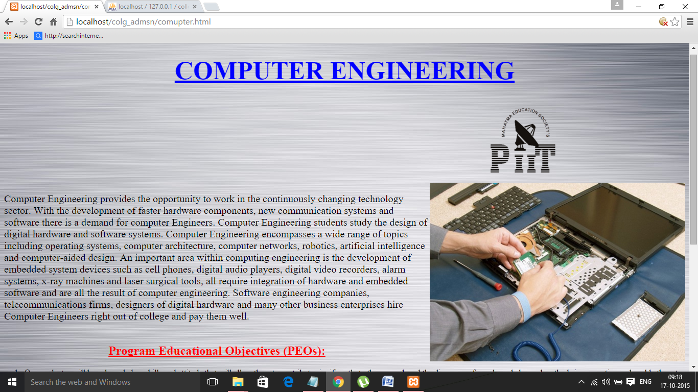

**Fig. 4.2.7:Computer Engineering Page**

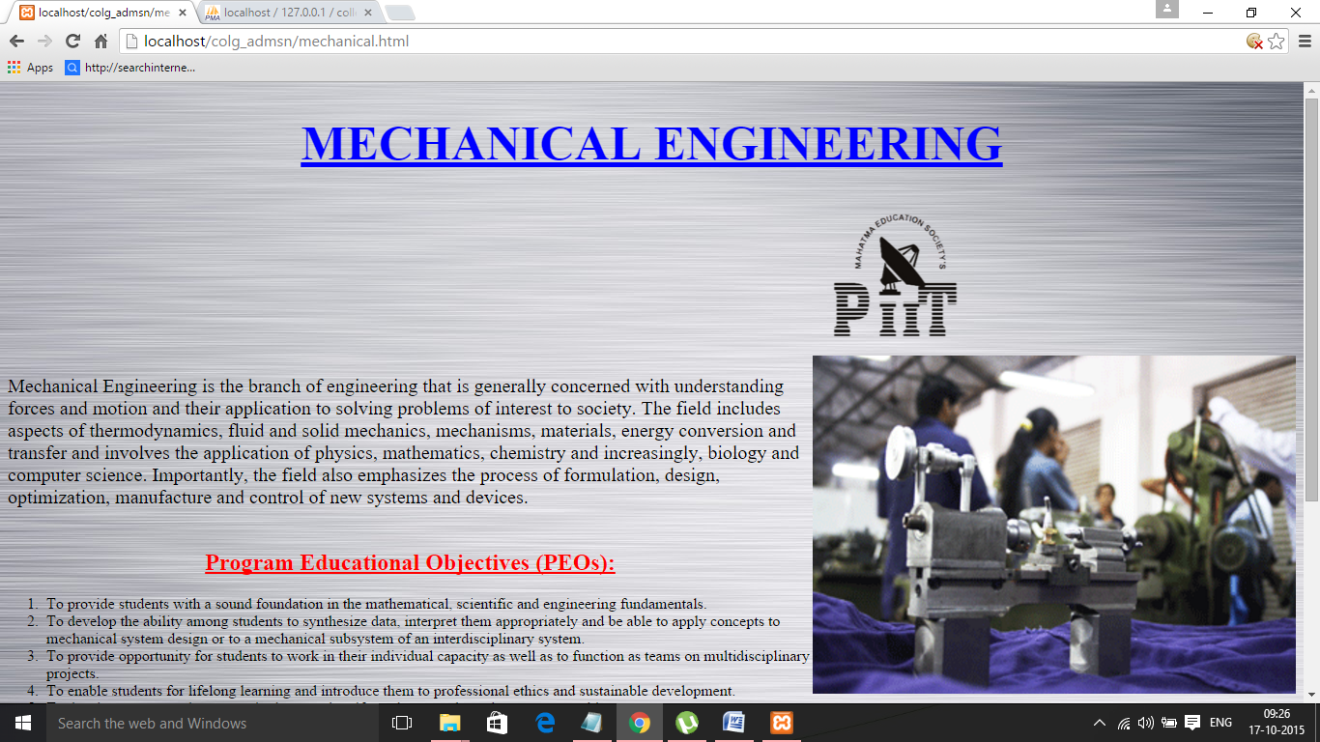

**Fig. 4.2.8:Mechanical Engineering Page**

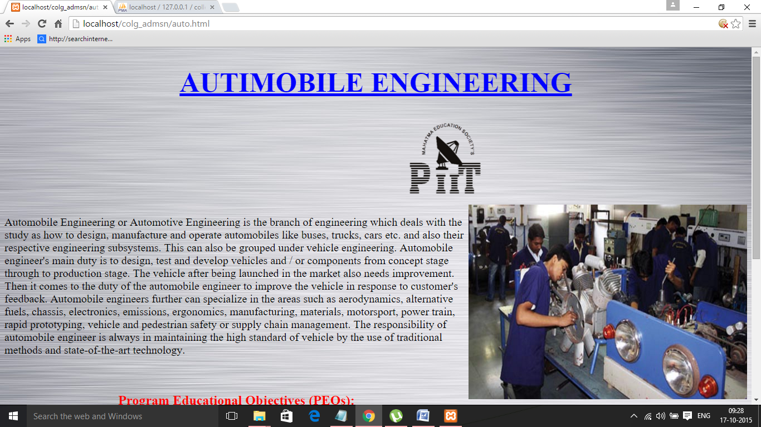

**Fig. 4.2.9:Automobile Engineering Page**

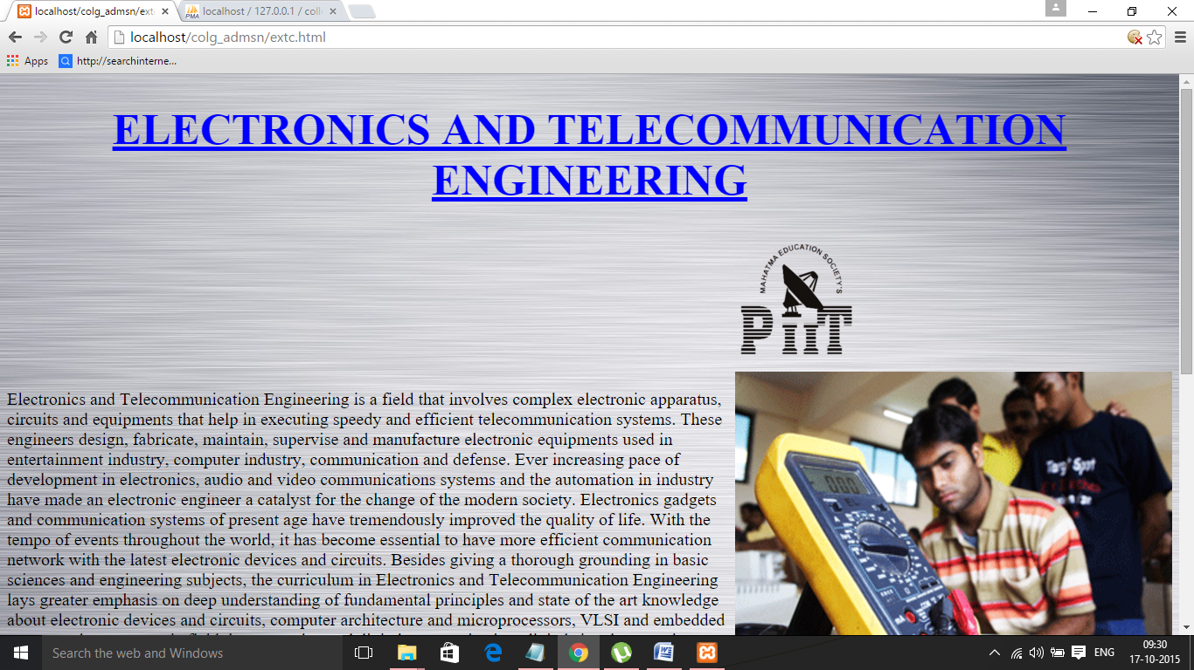

**Fig. 4.2.10:Electronics and Telecommunication Engineering Page**

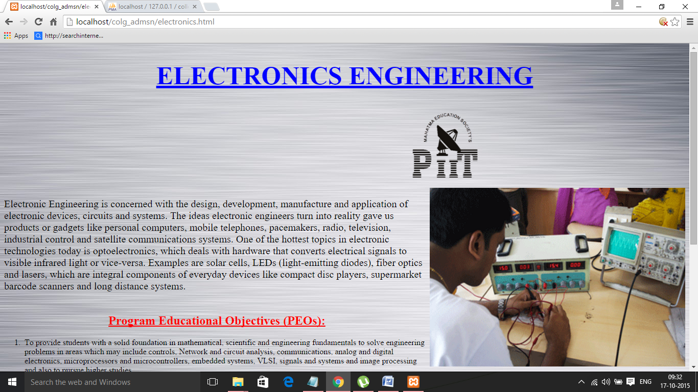

**Fig. 4.2.11:Electronics Engineering Page**

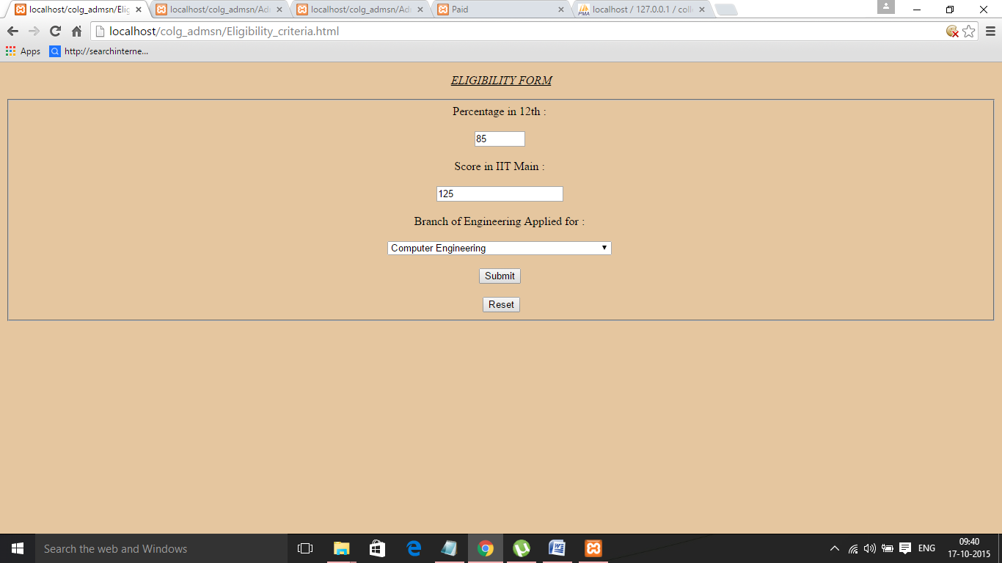

**Fig. 4.2.12:Eligibility Form Page**

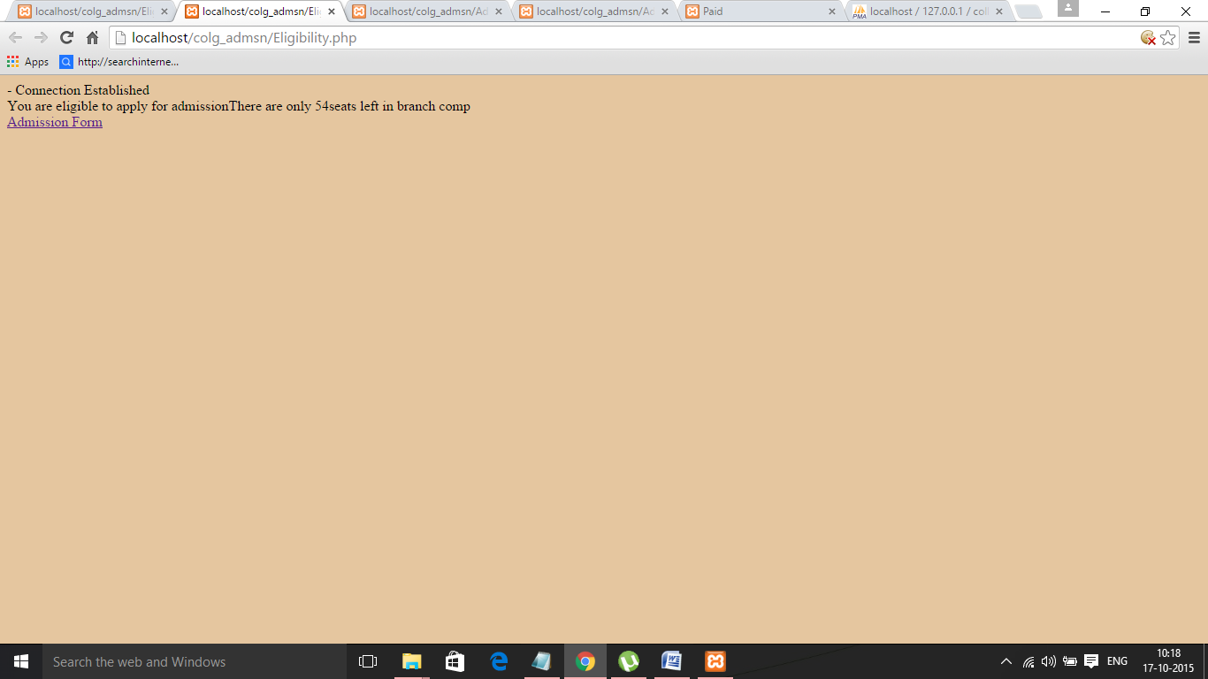

**Fig. 4.2.13:Eligibility Result Page**

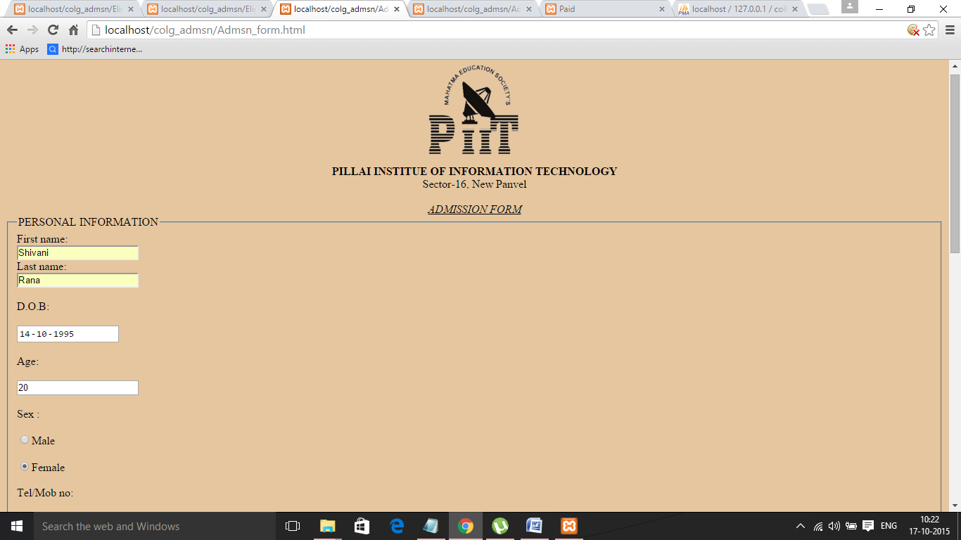

**Fig. 4.2.14:Admission Form Page**

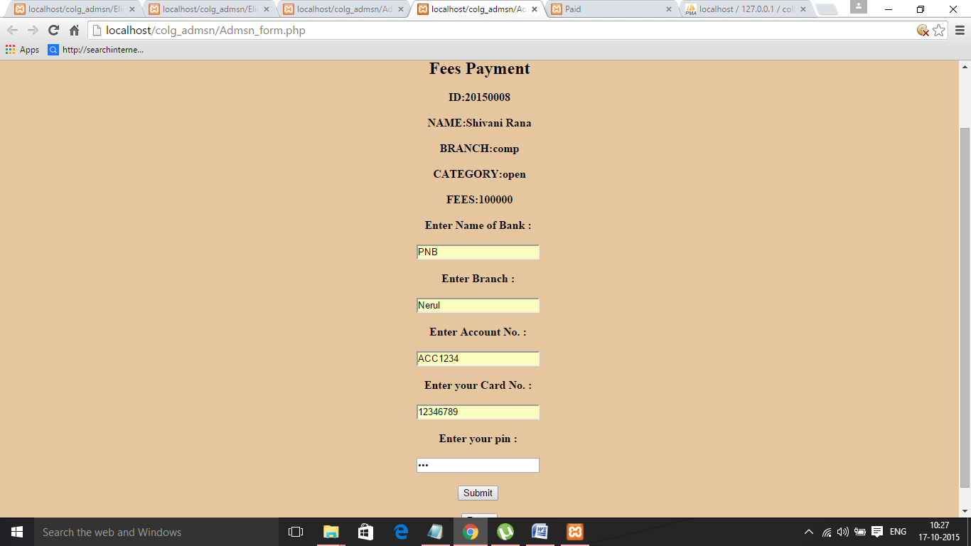

**Fig. 4.2.15: Fees Payment Form Page**



**Fig. 4.2.16: Admission Confirmation Page**

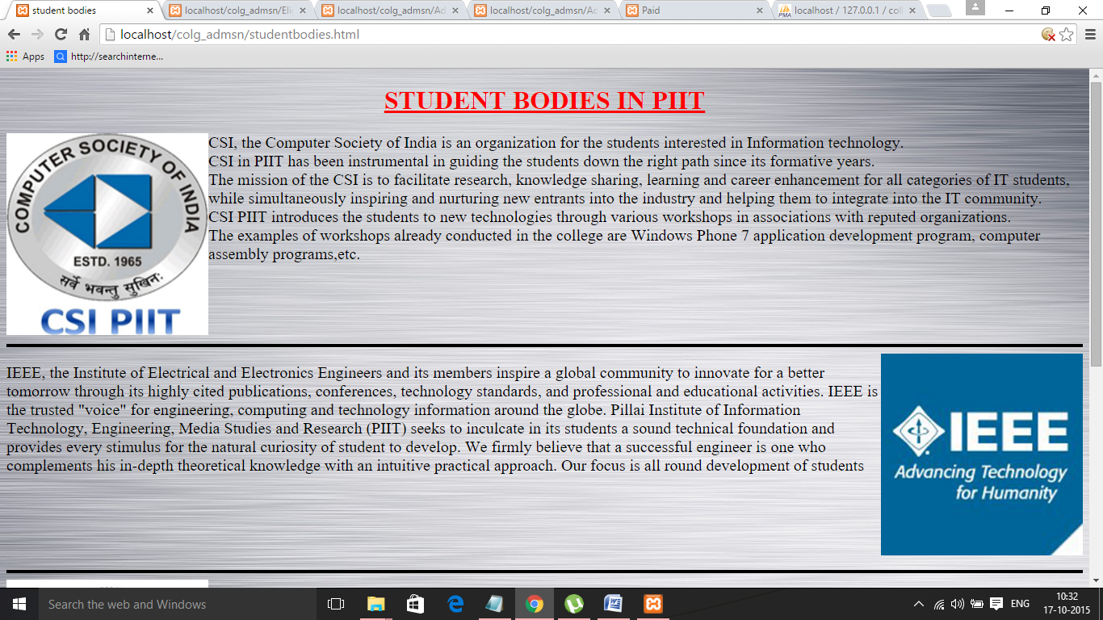

**Fig. 4.2.17:Student Bodies Page**

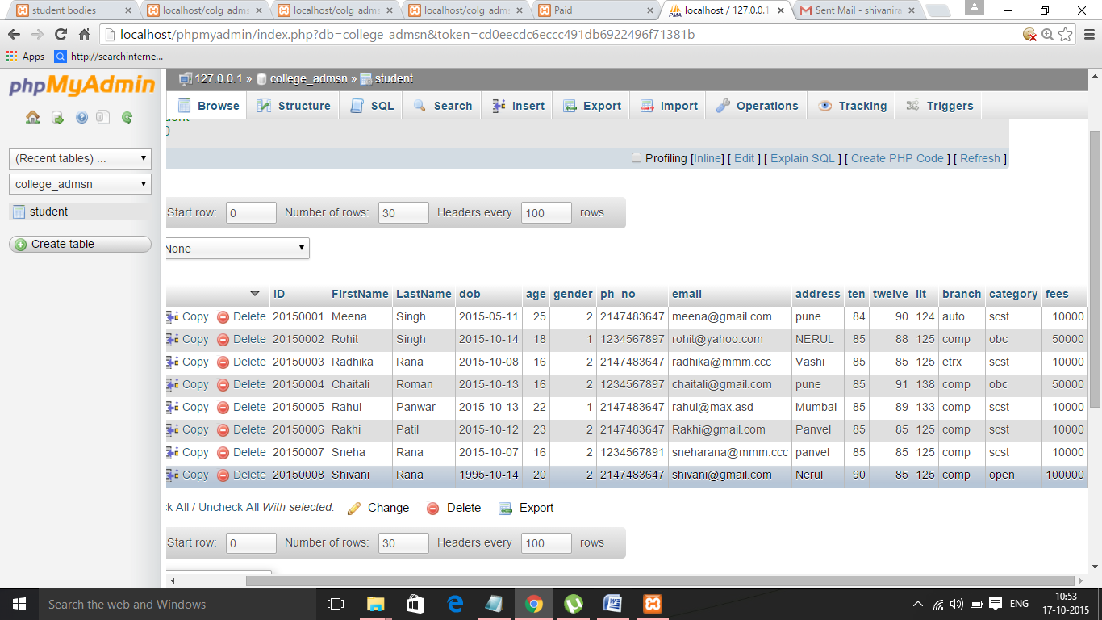

**Fig. 4.2.18:Database : Table "student"**

**Chapter 5**

**Conclusion**

**5.1 Summary**

We have designed and developed a website for Online College Admission System that provides the student the ability to browse through infrastructure and other details of the college and makes College Admission process online and simple.

**5.2 Future Scope**

The College Admission System can be expanded to a College Management System. Utilities for checking exam results online and displaying student's attendance online can be included. Students can also be given an option to form a user account on College website so that they can fill their admission form online and check their fees, attendance and exam results etc records.

**References**

**Websites:**

* **http://www.w3schools.com/**
* **http://www.w3schools.com/js/default.asp**
* **http://piit.ac.in/**